Integrated IoT-based Aquatic Debris Collection System

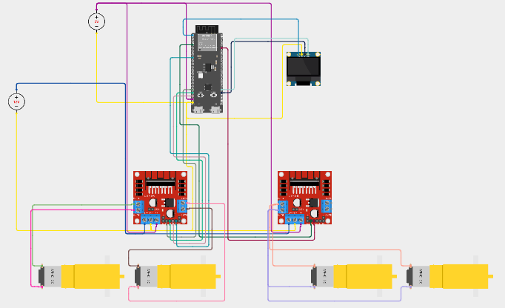
Circuit Diagram of Navigation, Collection, and Monitoring Unit

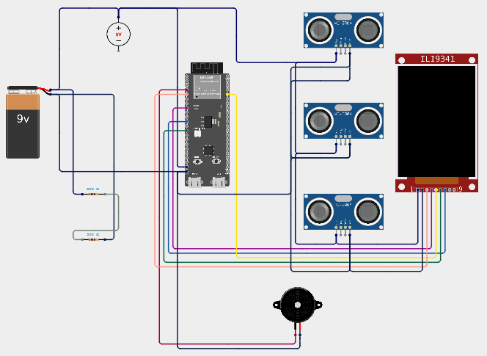
Circuit Diagram of Pond and Utility Monitoring Unit
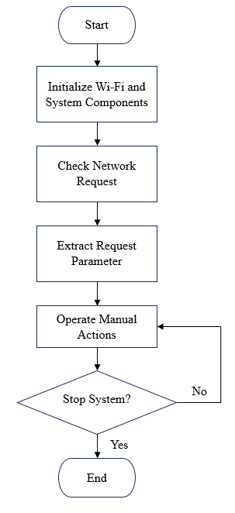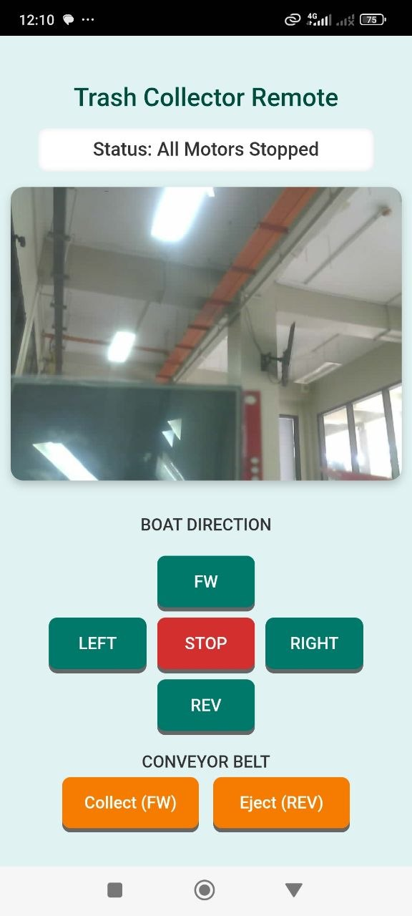
Flowchart and App Interface of Navigation, Collection, and Monitoring Unit

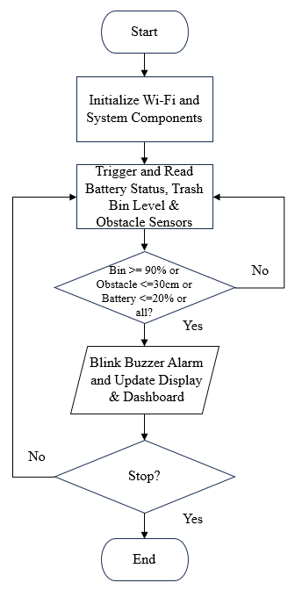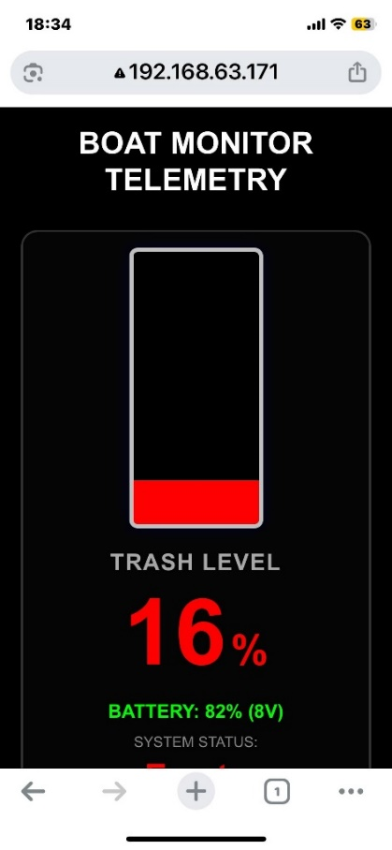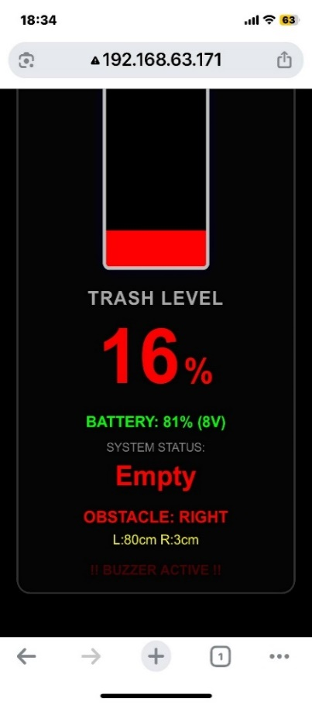
Flowchart and Web Dashboard of Pond and Utility Monitoring Unit

